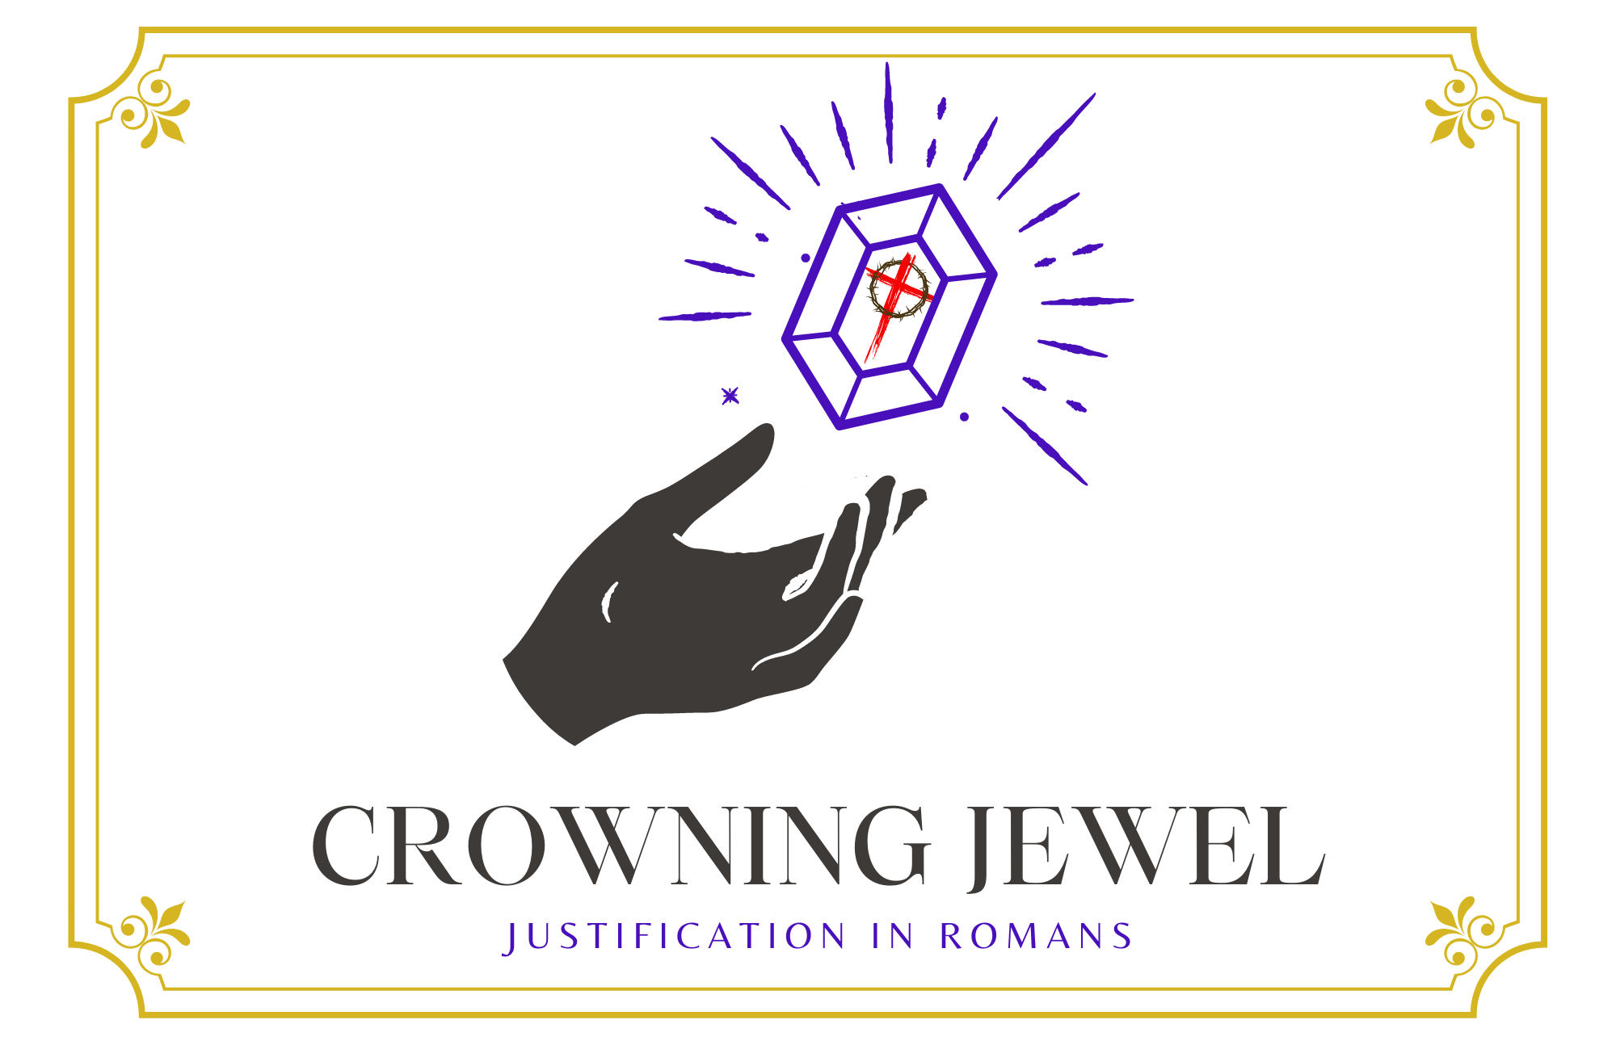

2nd Sunday in Lent

CHRIST LUTHERAN CHURCH | Lodi, California
February 25, 2023

WELCOME TO WORSHIP
Welcome to Christ Lutheran Church. We pray that your soul will be strengthened by the good news about God’s grace, love, and forgiveness given to us. If you would like to learn more about our church, please speak with our pastor or one of our members after the service.
- Bathrooms are located in the fellowship hall. A changing table is located in the women’s bathroom.
WORSHIP THEME
Christ is our peace. Though we go through trial and temptation, we face this world with the sure hope of eternal glory. Because Christ has reconciled us to God, we no longer need to fear anything—we stand in God’s grace.
One theologian has called justification the crowning jewel of Christian doctrine. Like a finely cut gemstone, this teaching of the Bible has many facets, and every time we examine it from a different angle, new truths and fresh insights come into view like light reflecting from its face. During the season of Lent, we will examine some of the various aspects of what Christ accomplished for us.
The Common Service
The high and holy worship of God is faith in Jesus Christ. Such faith is created and sustained by God’s service to us (the German, “Gottesdienst,” “The Divine Service”). In the Divine Service, the Lord comes to us in His Word and Sacrament to bless and enliven us with His gifts. The Service is not something we do for God, but His service to us received in faith. The liturgy is God’s work. He gives, we receive.
HYMN Why Should Cross and Trial Grieve Me | CW 428

INVOCATION
M: In the name of the Father, and of the Son ✙ and of the Holy Spirit
C: Amen.
CONFESSION
From God’s Word we know that wherever God puts His name, there He is to bless. In the Old Testament the temple was the place where God graciously caused His name to be present (1 Kings 8:27-30).
God has put His name —Father, Son, and Holy Spirit—on us in Holy Baptism. The Divine Service begins with the Invocation, the words spoken over us at our baptisms. Every Divine Service is for the hallowing of the Lord’s name, which the Small Catechism reminds us is done “when the Word of God is taught in its truth and purity, and we, as the children of God, also lead holy lives according to it” (Matthew 28:18-20).
M: Beloved in the Lord: let us draw near with a true heart and confess our sins to God our Father, asking him in the name of our Lord Jesus Christ to grant us forgiveness.
C: Holy and merciful Father, I confess that I am by nature sinful, and that I have disobeyed you in my thoughts, words, and actions. I have done what is evil and failed to do what is good. For this I deserve your punishment both now and in eternity. But I am truly sorry for my sins, and trusting in my Savior Jesus Christ, I pray: Lord, have mercy on me, a sinner.
Lord, have mercy on us. Christ, have mercy on us. Lord, have mercy on us.

absolution
M: God, our heavenly Father, has been merciful to us and has given his only Son to be the atoning sacrifice for our sins. Therefore, as a called servant of Christ and by his authority, I forgive you all your sins in the name of the Father and of the Son ✙ and of the Holy Spirit.
C: Amen

PRAYER OF THE DAY
M: The Lord be with you.
C: And also with you.

M: Let us pray.
Almighty God, you see that we have no power to defend ourselves. Guard and keep us both outwardly and inwardly from all adversities that may happen to the body and from all evil thoughts that may assault and hurt the soul; through Jesus Christ our Lord, who lives and reigns with you and the Holy Spirit, one God, now and forever.
C: Amen
FIRST LESSON Genesis 28:10–17
As Jacob flees his brother, God comforts him with His presence.
¹⁰ Jacob left Beersheba and set out for Harran. ¹¹ When he reached a certain place, he stopped for the night because the sun had set. Taking one of the stones there, he put it under his head and lay down to sleep. ¹² He had a dream in which he saw a stairway resting on the earth, with its top reaching to heaven, and the angels of God were ascending and descending on it. ¹³ There above it stood the Lord, and he said: “I am the Lord, the God of your father Abraham and the God of Isaac. I will give you and your descendants the land on which you are lying. ¹⁴ Your descendants will be like the dust of the earth, and you will spread out to the west and to the east, to the north and to the south. All peoples on earth will be blessed through you and your offspring. ¹⁵ I am with you and will watch over you wherever you go, and I will bring you back to this land. I will not leave you until I have done what I have promised you.”
¹⁶ When Jacob awoke from his sleep, he thought, “Surely the Lord is in this place, and I was not aware of it.” ¹⁷ He was afraid and said, “How awesome is this place! This is none other than the house of God; this is the gate of heaven.”
PSALM Psalm 73, CW’21
SECOND LESSON Romans 5:1–11
Christ is our peace.
5 Therefore, since we have been justified through faith, we have peace with God through our Lord Jesus Christ, ² through whom we have gained access by faith into this grace in which we now stand. And we boast in the hope of the glory of God. ³ Not only so, but we also glory in our sufferings, because we know that suffering produces perseverance; ⁴ perseverance, character; and character, hope. ⁵ And hope does not put us to shame, because God’s love has been poured out into our hearts through the Holy Spirit, who has been given to us.
⁶ You see, at just the right time, when we were still powerless, Christ died for the ungodly. ⁷ Very rarely will anyone die for a righteous person, though for a good person someone might possibly dare to die. ⁸ But God demonstrates his own love for us in this: While we were still sinners, Christ died for us.
⁹ Since we have now been justified by his blood, how much more shall we be saved from God’s wrath through him! ¹⁰ For if, while we were God’s enemies, we were reconciled to him through the death of his Son, how much more, having been reconciled, shall we be saved through his life! ¹¹ Not only is this so, but we also boast in God through our Lord Jesus Christ, through whom we have now received reconciliation.
VERSE OF THE DAY Philippians 2:8
Jesus humbled himself and became obedient to death, even death on a cross.
THE GOSPEL Mark 8:31–38
Christ calls his disciples to take up their cross and follow him. Though the way of the Christian will involve pain, it will end with our lives being saved.
³¹ He then began to teach them that the Son of Man must suffer many things and be rejected by the elders, the chief priests and the teachers of the law, and that he must be killed and after three days rise again. ³² He spoke plainly about this, and Peter took him aside and began to rebuke him.
³³ But when Jesus turned and looked at his disciples, he rebuked Peter. “Get behind me, Satan!” he said. “You do not have in mind the concerns of God, but merely human concerns.”
³⁴ Then he called the crowd to him along with his disciples and said: “Whoever wants to be my disciple must deny themselves and take up their cross and follow me. ³⁵ For whoever wants to save their life will lose it, but whoever loses their life for me and for the gospel will save it. ³⁶ What good is it for someone to gain the whole world, yet forfeit their soul? ³⁷ Or what can anyone give in exchange for their soul? ³⁸ If anyone is ashamed of me and my words in this adulterous and sinful generation, the Son of Man will be ashamed of them when he comes in his Father’s glory with the holy angels.”

M This is the Gospel of the Lord.
C: Praise be to you, O Christ!

APOSTLES’ CREED
I believe in God, the Father Almighty,
maker of heaven and earth.
I believe in Jesus Christ, his only Son, our Lord,
who was conceived by the Holy Spirit,
born of the Virgin Mary,
suffered under Pontius Pilate,
was crucified, died, and was buried.
He descended into hell.
The third day he rose again from the dead.
He ascended into heaven
and is seated at the right hand of God the Father Almighty.
From there he will come to judge the living and the dead.
I believe in the Holy Spirit,
the holy Christian Church,
the communion of saints,
the forgiveness of sins,
the resurrection of the body,
and the life everlasting. Amen.
HYMN OF THE DAY Blessed Are the Saints of God| CW 394
SERMON Romans 5
OFFERTORY
C: Create in me a clean heart, O God,
And renew a right spirit within me.
Cast me not away from your presence
And take not your Holy Spirit from me.
Restore unto me the joy of your salvation,
And uphold me with your free Spirit. Amen.

OFFERING
In response to God’s love and forgiveness, we give back a portion of what he has given us. The members of Christ Lutheran Church have joined to proclaim the gospel to this community. These offerings support that work. While our guests are welcome to participate, they should not feel obligated to do so.
PRAYER OF THE CHURCH
M: Heavenly Father, give us Your Holy Spirit, that we might deny ourselves, take up the crosses You give and follow Your Son through this troubled life into heaven. Prepare us to give up our lives, knowing that Christ has already saved them. Lord, in Your mercy,
C: Hear our prayer.
M: O Lord, give the Church and all her servants grace to fulfill the ministries to which You have committed them. Grant each of us the strength to confess Christ boldly before the world. Lord, in Your mercy,
C: Hear our prayer.
M: Heavenly Father, teach us to shun neither our Lord’s suffering nor our own. When we endure persecution or ridicule for being Your children, give us faith and perseverance. As You have promised, deliver us out of the hand of the wicked and redeem us from the grasp of the ruthless. Lord, in Your mercy,
C: Hear our prayer.
M: O God, Abraham was only one when You called him, but You blessed and multiplied him. Protect mothers with child, and equip fathers to lead and raise their households in Your fear and love. Lord, in Your mercy,
C: Hear our prayer.
M: O Lord, all kingship belongs to You, and You rule over the nations. Bless our president and all those who govern, that they may rule wisely and in accord with Your will. Lord, in Your mercy,
C: Hear our prayer.

M: Great Physician, heal and restore. Give Your holy care and strength to all who must bear their crosses of sickness and infirmity, that they may endure until they see the Son of Man coming in His kingdom. Lord, in Your mercy,
C: Hear our prayer.
M: Heavenly Father, receive our praise this day for St. Peter and his confession that Jesus is the Christ. We rejoice that Your Son builds His Church upon this rock and that the gates of hell cannot prevail against it. Keep us in this faith all our days; through the same Jesus Christ, Your Son, our Lord, who lives and reigns with You and the Holy Spirit, one God, now and forever.
C: Amen.

LORD’S PRAYER Matthew 6:9-13; Luke 11:2-4
C: Our Father in heaven,
hallowed be your name,
your kingdom come,
your will be done on earth as in heaven.
Give us today our daily bread;
and forgive us our sins,
as we forgive those
who sin against us;
and lead us not into temptation,
but deliver us from evil.
For the kingdom, the power,
and the glory are yours
now and forever. Amen.

THE BLESSING
M: The Lord bless you and keep you.
The Lord make his face shine on you and be gracious to you.
The Lord look on you with favor and ✙ give you peace.
C: Amen.
CLOSING HYMN It Is Well With My Soul| CW’21 850
WELS CONNECTION

COPYRIGHT INFORMATION
Content requiring a copyright license is reproduced under OneLicense.net #A-718312. All rights reserved. The Common Service: Texts revised from The Lutheran Hymnal, 1941. Music revised by James Engel. Scripture Quotations: From the Holy Bible, New International Version (NIV 1984), © 1973, 1978, 1984 by Biblica, Inc.

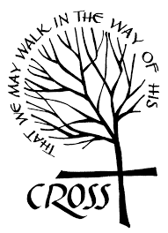

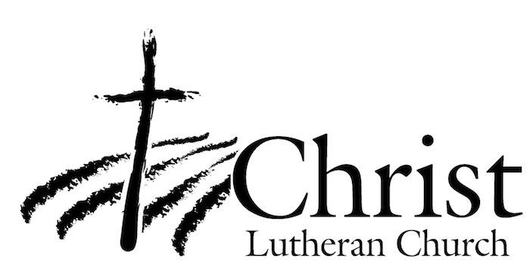
13009 N. Elderberry Ct.
Lodi, CA 95242
www.christlodi.org
209-368-6250
Pastor Timothy Leistekow
WELCOME TO CHRIST EV. LUTHERAN CHURCH!
We preach a message of forgiveness, hope and peace
through the death and resurrection of Jesus Christ.
Families and individuals of all ages will find opportunities
both to grow and to serve.
Our mission statement:
Look what Christ is doing!
He binds us together in fellowship
He gathers us in for worship
He builds us up for service
He sends us out with the gospel

“Now you are the body of Christ,
and each one of you is a part of it.”
(1 Corinthians 12:27)

